System Design
Data Flow Diagram
Admin(Agriculture Officer)
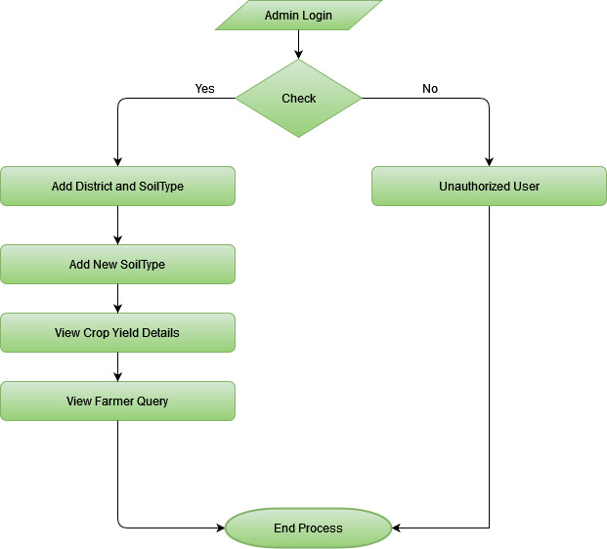

User(Farmer)
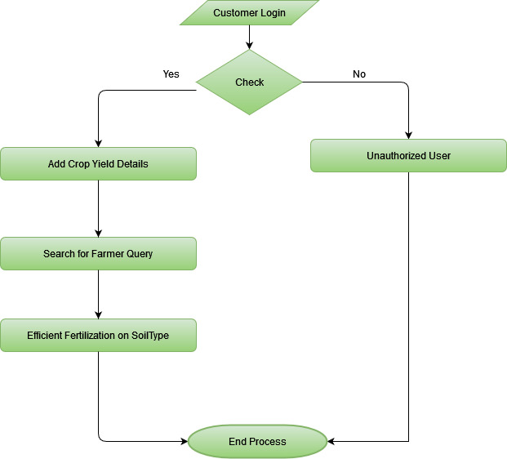

Usecase Diagram
Admin(Agricultural Officer)
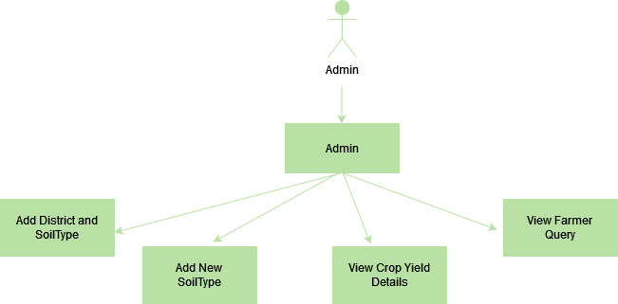

User(Customer)
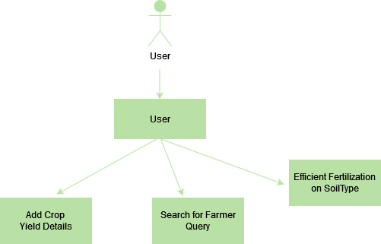

Class Diagram

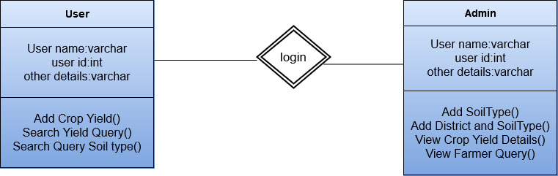

Sequence Diagram
Admin(Agricultural Officer)
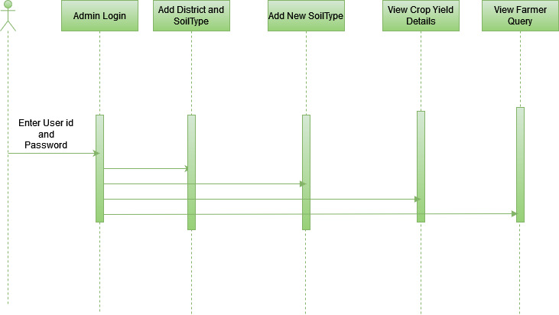

User(Customer)
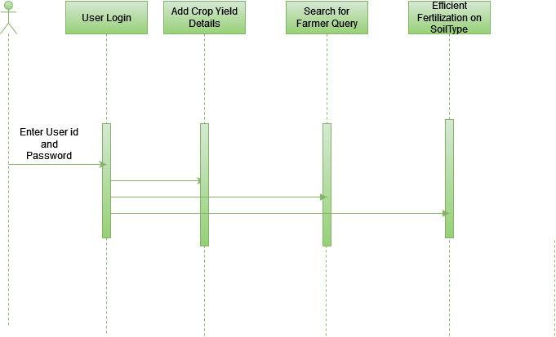
Activity Diagram
Admin(Agricultural Officer)
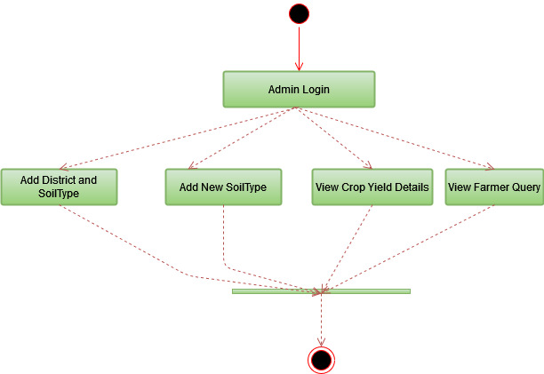
User(Customer)
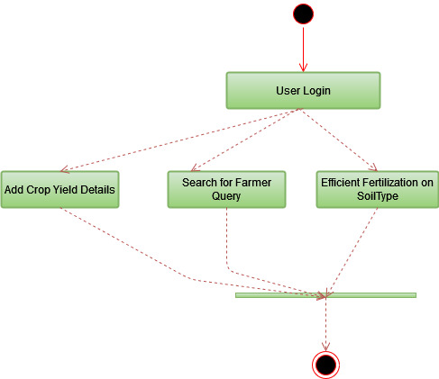
Component Diagram
Admin(Agricultural Officer)

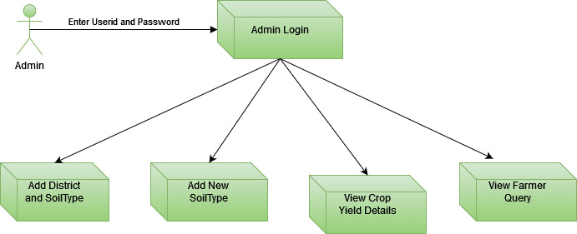

User(Customer)
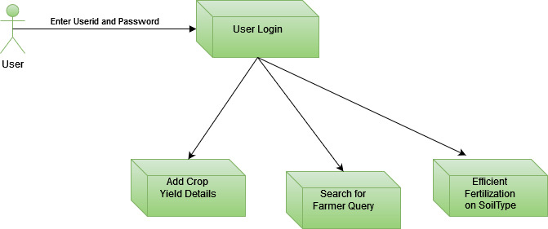

ER Diagram
Admin(Agricultural Officer)
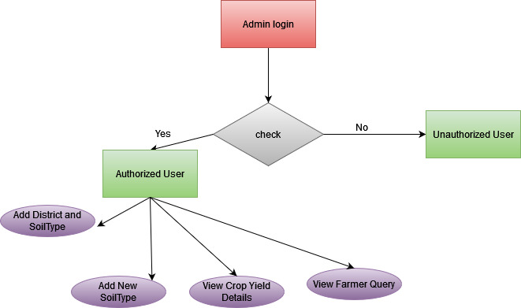

User(Customer)
